Project troubleshoot:
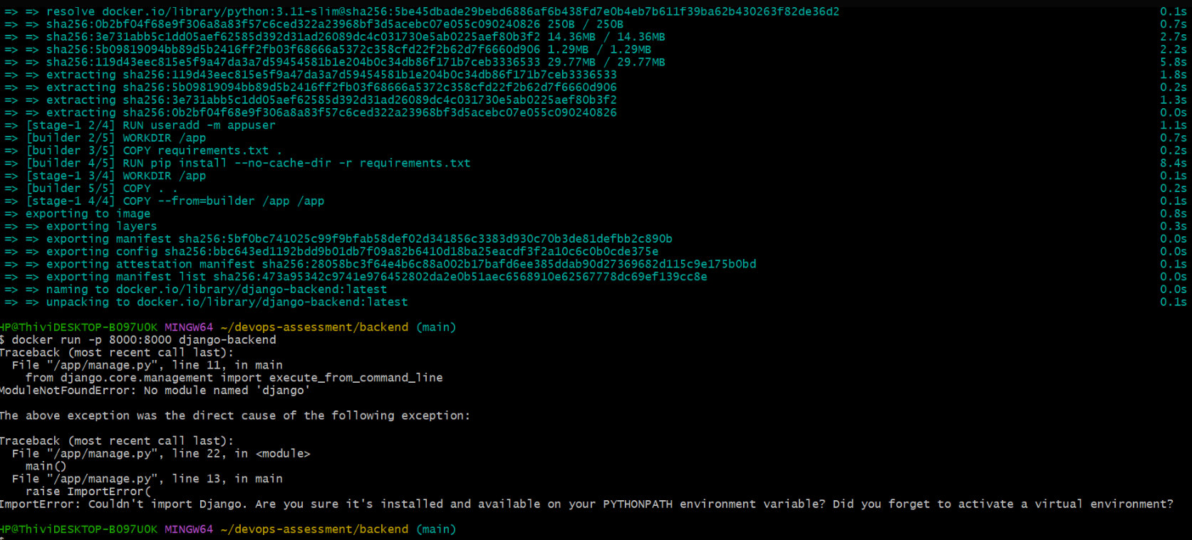
Django was installed in builder stage but python package wasn’t copied to runtime
So I Installed dependencies again in runtime
COPY requirements.txt .
RUN pip install --no-cache-dir -r requirements.txt
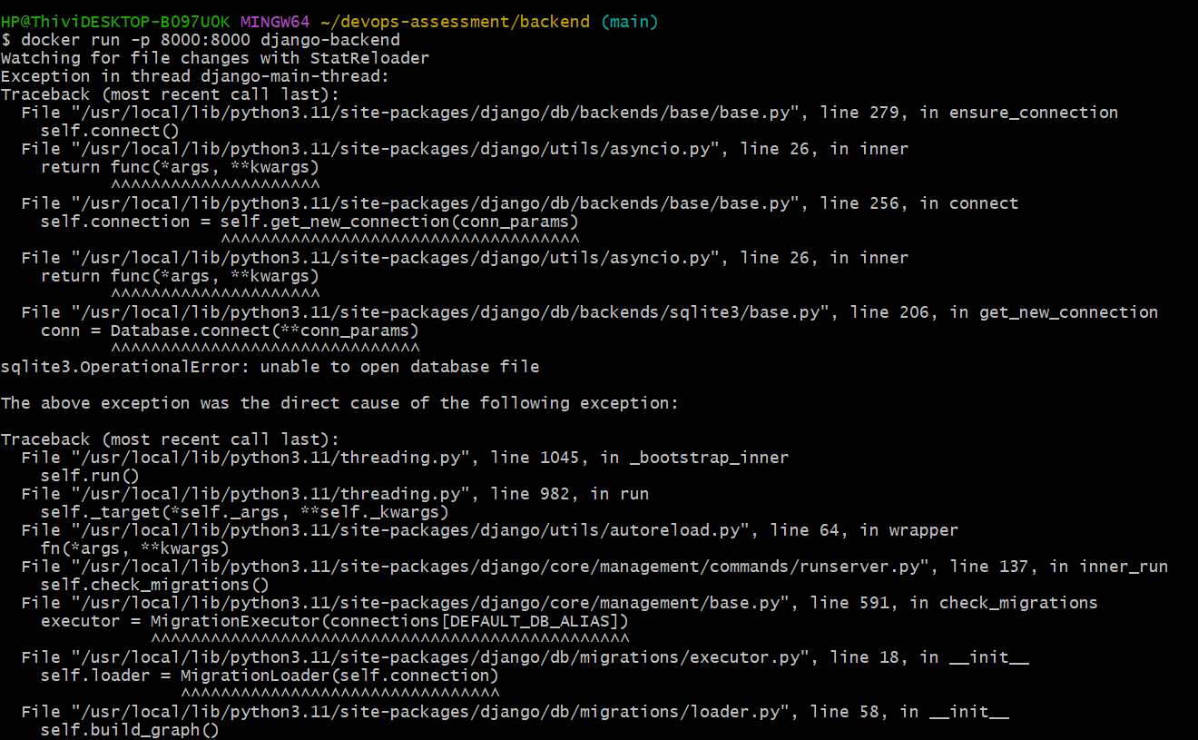
Settings.py contains ‘corsheaders’, but that package is not installed inside corsheaders.

So I updated requirements.txt file to
Django
djangorestframework
django-cors-headers

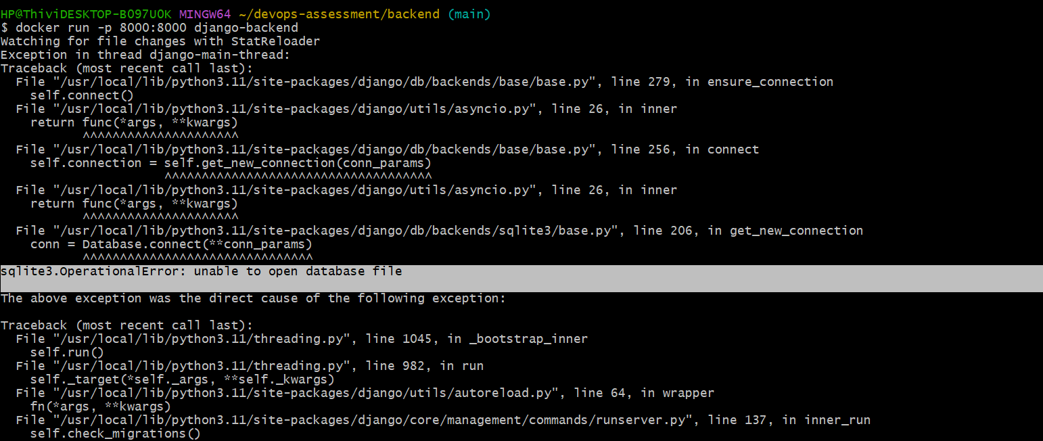
While running Django as a non-root user ,I found this error due to user permission issues.
I resolved it by assigning proper ownership to the application directory.
So I added this in a docker file
RUN mkdir -p /app/data && chown -R appuser:appuser /app
Rebuild the image

GitHub push permission denied (403)
Problem: GitHub rejected password-based authentication.
Solution: Used GitHub Personal Access Token (PAT) for secure authentication

